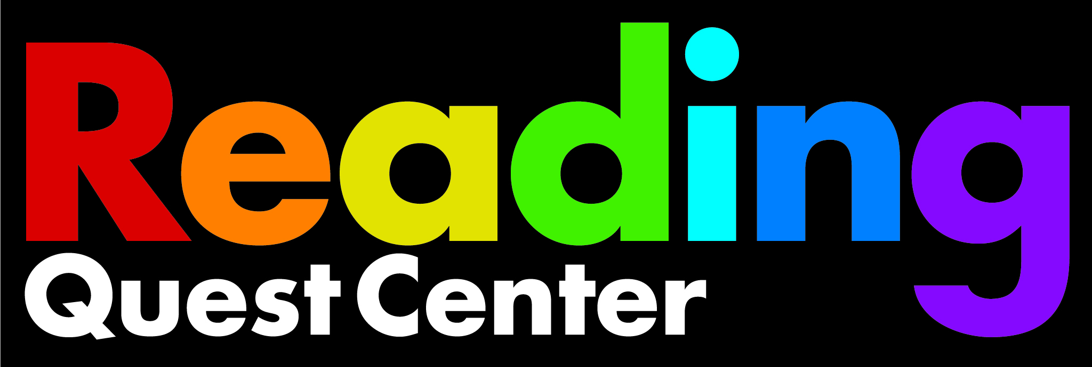
The Science of Reading: Suggested Articles

Mark Seidenberg: The Gap Between Science and Reading and How it is Taught

Emily Hanford: Kids Struggle to Read when Schools Leave Phonics Out:

Emily Hanford: Why Millions of Kids Can’t Read and What Better Teaching Can Do About it

Emily Hanford: Hard Words. Why Aren’t Kids Being Taught to Read:

The Reading Wars by Nicholas Lemann

We Know How to Teach Kids to Read by John McWhorter

How a flawed idea is teaching millions of kids to be poor readers by Emily Hanford

Emily Hanford: Why are We Still Teaching Reading the Wrong Way?

Emily Hanford: Hard to Read: How American Schools are Failing Dyslexic Students

Mark Seidenberg: Language at the Speed of Sight

Alexander Russo: Why Reading Went under the Radar for so Long

David Liben: A Simple Step towards Improving Student Literacy (Building Vocabulary is Vital to learning to how to Read)

Nell K. Duke, Heidi Anne E. Mesmer: Phonics Faux Pas (Avoiding Instructional Missteps in Teaching Letter-Sound Relationships)

Alexander Russo: The Grade (Closing the Achievement Gap)

Research Articles

Ending the Reading Wars: Reading Acquisition From Novice to Expert

By Anne Castles, Kathleen Rastle, Kate Nation

